Implementation & Evaluation Plan
AI-Based Building-Cluster Flood Vulnerability Mapping
Using Satellite Imagery and Geospatial Data (Kochi / Periyar Basin, Kerala)
Version 2 — revised to address building-level resolution limits, single-source validation risk, and scoring scope
Aligned against base paper: Mohamadiazar et al. (2024), Journal of Hydrology

1. Scope Statement — Read This First
This project is specifically about flood risk, not general urban-planning risk. We do not evaluate traffic, amenities, seismic risk, or general "quality of planning." Every dataset, every metric, and every score in this document measures one thing: how vulnerable a location is to flooding, based on elevation, water proximity, land cover, and historical flood evidence. We use the precise term
"Flood Vulnerability Score" throughout this document — never "flood prediction" and never "risk" used vaguely — because we are estimating relative vulnerability from known contributing factors, not forecasting the probability of a future event.

2. What Changed From Version 1, and Why
Version 1 (earlier plan) | Version 2 (this document) | Why it changed
Scored only newly detected construction | Scores every building/land unit in the study area; new construction becomes an overlay tag | Restricting to new construction discarded most of the segmentation output and made the citizen "check before building" feature not actually work on empty land
Building-level risk claims | Grid-cell / building-cluster level claims | Sentinel-2 is 10 m resolution — a single house is often smaller than one pixel. Claiming individual building precision overclaims what the data can support
DFO 2018 as the sole ground truth | DFO 2018 + supplementary Sentinel-1-derived flood extent + local records, used together | DFO flood products are relatively coarse (regional-scale, documented resolution limitations); a single coarse source cannot be treated as precise ground truth on its own
Two land-cover classes (building, vegetation) | Five land-cover classes (building, vegetation, water, impervious surface, bare land) | More classes give richer, more defensible risk factors (e.g. imperviousness as a runoff proxy) instead of relying on only two
"Risk score" used loosely | "Flood Vulnerability Score", explicitly not a probability | Avoids implying a calibrated probability of flooding without the historical event data that would justify one
Precision/Recall/F1/AUC only | Adds IoU and Dice coefficient for segmentation; adds ROC-AUC/PR-AUC framing for risk validation | Pixel accuracy and F1 alone are not sufficient for segmentation quality; PR-AUC matters because flooded/high-risk areas are a minority class

3. Research Question
"Can satellite-based land-cover segmentation, multi-year change detection, and geospatial hazard factors be combined to estimate the relative flood vulnerability of buildings and building clusters, and to identify newly developed areas that fall within potentially vulnerable zones?"
This framing — vulnerability estimation and growth analysis, not flood prediction — is what we present to the guide and panel.

4. Implementation Plan

4.1 Stage 1 — Data Collection & Alignment
Layer | Source | Resolution | Role
Optical satellite imagery (2 years) | Sentinel-2 Level-2A, AWS Earth Search STAC | 10 m, bands B02/B03/B04/B08 | Land-cover segmentation; change detection
Radar satellite imagery (supplementary) | Sentinel-1 SAR, Copernicus | 10 m | Cloud-penetrating cross-check for Kerala's monsoon cloud cover; supplementary flood-extent signal for validation
Elevation | Copernicus Global DEM (GLO-30) | ~30 m | Low-lying zone identification (relative elevation, not exact per-building height)
Water bodies / rivers | OpenStreetMap hydrography | Vector | Distance-to-water computation
Building footprints (labels) | OSM + Microsoft Global ML Building Footprints + Google Open Buildings v3 | Vector polygons | Training/testing labels for segmentation; building-cluster definition
All layers are resampled onto one shared grid and coordinate system before further processing. Sentinel-1 is included specifically because Kerala's monsoon-heavy climate frequently produces cloud cover that blocks optical Sentinel-2 imagery — Sentinel-1's radar sees through cloud and works day or night.

4.2 Stage 2 — Multi-Class Land-Cover Segmentation
- Model: DeepLabV3+ (or U-Net), pretrained on ImageNet, fine-tuned on local labels
- Classes (5, not 2): Building, Vegetation, Water, Impervious surface / road, Bare land
- Unit of analysis: building clusters / fixed grid cells aligned to imagery resolution — not individual buildings, to avoid overclaiming precision below the sensor's real resolution
- Train/test split: 70% / 30%, with data augmentation (flip, rotation) — same convention as the base paper

4.3 Stage 3 — Multi-Year Change Detection
The trained model is run on the earlier-year and later-year image sets, and outputs are compared per grid cell / cluster to flag newly developed or expanded built-up clusters. This module answers "where has growth happened" and feeds a growth-trend tag into the scoring stage — it is not the gatekeeper for whether a location gets scored at all.

4.4 Stage 4 — Geospatial Feature Extraction
For every grid cell / building cluster in the study area (not only new construction), we compute:
- Elevation and relative elevation (Copernicus DEM)
- Distance to nearest water body (OpenStreetMap)
- Local slope (derived from DEM)
- Imperviousness proxy (share of impervious/road class in and around the cell — a runoff indicator)
- Vegetation share (a partial drainage/absorption indicator)
- Historical flood exposure (whether this cell fell inside a documented past flood extent)

4.5 Stage 5 — Weighted Flood Vulnerability Scoring
Flood Vulnerability Score =
w1 x elevation_risk
+ w2 x water_proximity_risk
+ w3 x historical_flood_exposure
+ w4 x impervious_surface_share
+ w5 x slope_risk
+ w6 x (1 - vegetation_share)
Normalized to a 0-100 scale:
0-20 Very Low
21-40 Low
41-60 Moderate
61-80 High
81-100 Very High
Initial weights (w1...w6) are assigned manually based on established flood-hydrology literature (elevation and water proximity weighted highest, consistent with the base paper's own finding that these factors matter most). This is disclosed explicitly as a heuristic starting point. As a stretch goal, weights can later be learned from data (e.g. logistic regression against the historical flood-extent labels) instead of set manually — noted as a future extension, not a current claim.
Every scored cell/cluster also carries a factor-level breakdown ("why is this score high") for explainability, and a separate "recently developed" tag from Stage 3 where relevant — the growth-trend overlay.

4.6 Stage 6 — Validation
Vulnerability scores are compared against real historical flood evidence for the 2018 Kerala floods, combining more than one independent source rather than relying on a single dataset (see Section 6).

4.7 Stage 7 — Dashboard
A planner/authority view (zone-level vulnerability map with growth-trend overlay) and a citizen-facing lookup (plain-language, explainable summary for any searched location, including empty/undeveloped land) are both served from the same underlying score.

5. Implementation Block Diagram
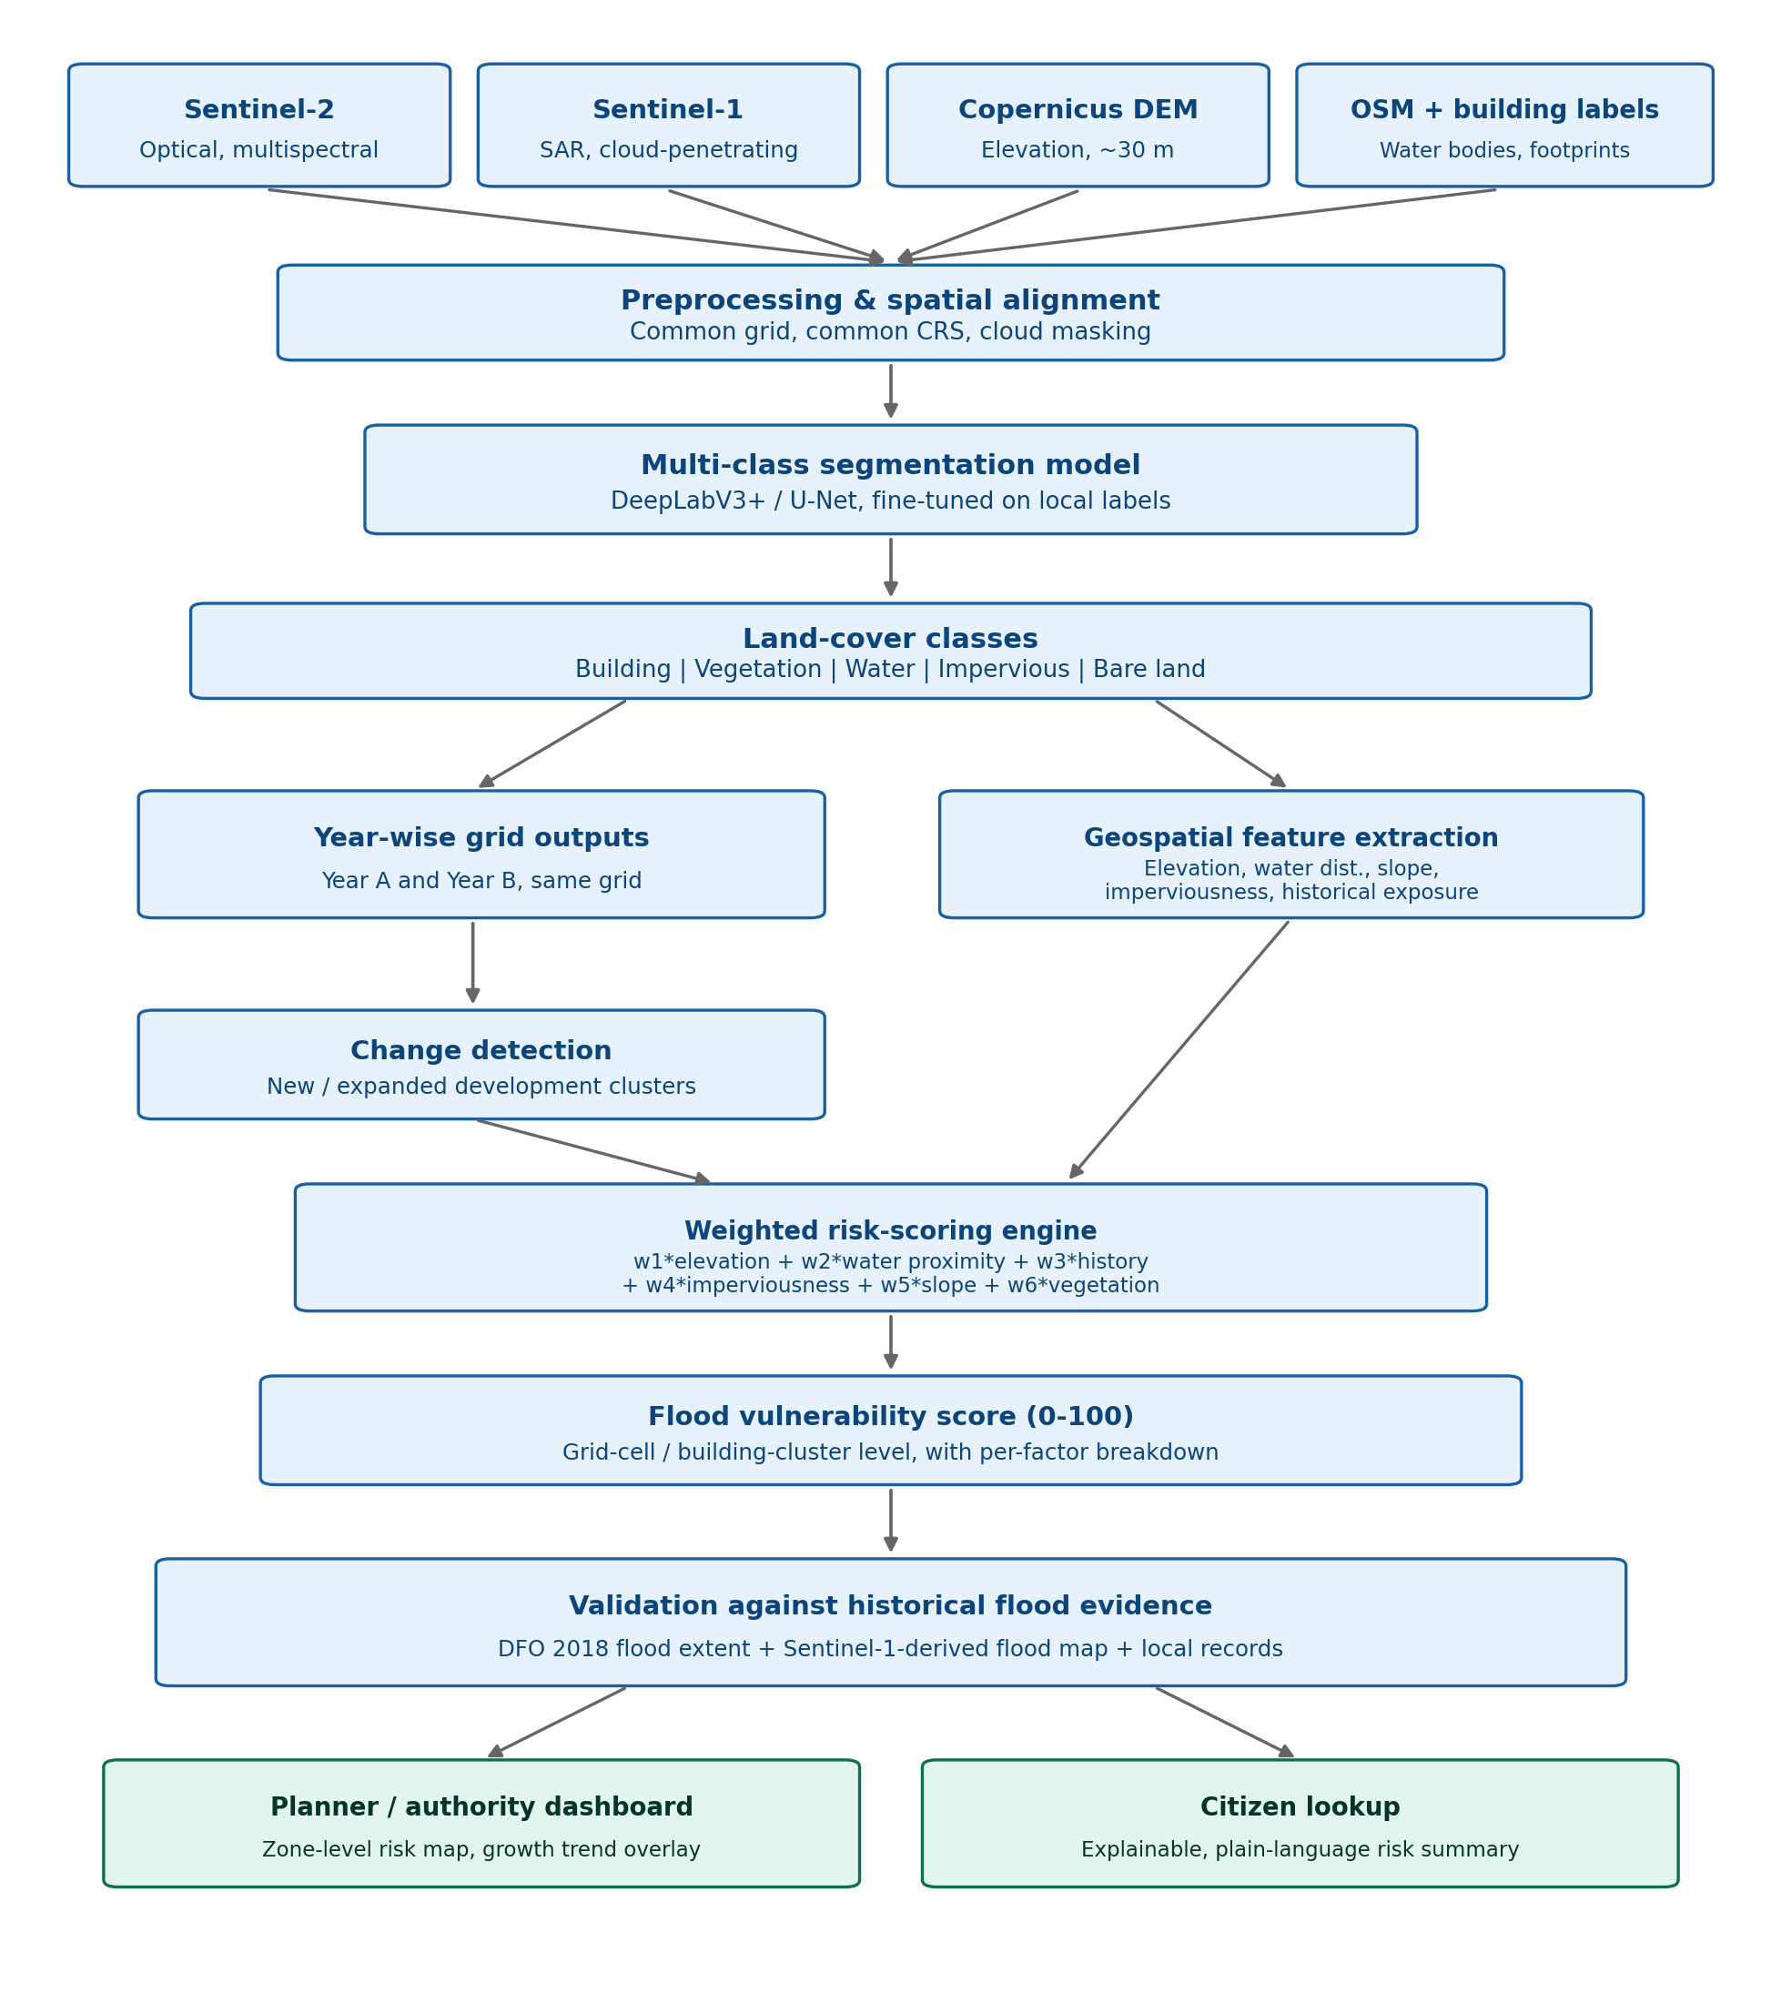

6. Validation — Ground Truth, Handled Honestly

6.1 Why DFO Alone Is Not Enough
DFO's flood-extent products are documented as relatively coarse (regional-scale, on the order of ~250 m in places), and DFO itself notes that not all flooding is reliably mappable from satellite data. Treating a DFO polygon as proof that one specific building or cluster flooded would be an overclaim. We therefore use DFO as one of several independent evidence sources, not as the sole ground truth.

6.2 Our Multi-Source Validation Approach
Source | What it adds | Resolution / caveat
Dartmouth Flood Observatory (DFO), 2018 Kerala event | Independent, publicly documented regional flood-extent polygon | Coarser resolution; regional-scale, not per-building
Sentinel-1 SAR-derived flood extent (supplementary, self-derived if feasible) | A finer-resolution, radar-based cross-check for the same 2018 event | Depends on scene availability for the exact flood dates
Local records / news coverage of the 2018 floods | Qualitative cross-check for specific known-affected localities | Not systematic or exhaustive; used as a sanity check only

6.3 How the Comparison Works (Grid-Cell / Cluster Level)
- Overlay our Flood Vulnerability Score map on the same grid as the combined flood-evidence layer
- For each cell/cluster, treat "did this location fall inside documented flood extent" as a binary label
- Compare against our vulnerability score using both a threshold-based Risk Validation Rate and a threshold-free ROC-AUC / PR-AUC curve
Risk Validation Rate = (High/Very-High cells overlapping documented flood extent
/ Total High/Very-High cells flagged) x 100%
PR-AUC used alongside ROC-AUC because flooded cells are a minority class
(class imbalance) - PR-AUC is more informative than ROC-AUC alone in this case
This is the direct structural equivalent of the base paper's Ground Truth Index (84.05%), but built from multiple evidence sources and reported at the resolution our data actually supports, not at an implied building-level precision.

7. Evaluation Parameters

7.1 Segmentation Quality
Metric | Formula / meaning | Why included
Pixel Accuracy | (TP+TN)/(TP+TN+FP+FN) | Overall correctness, comparable to base paper
Precision | TP/(TP+FP) | Comparable to base paper
Recall | TP/(TP+FN) | Comparable to base paper
F1 Score | 2 x P x R / (P+R) | Comparable to base paper
IoU (Intersection over Union) | Overlap / union of predicted vs. true region | Standard, stricter segmentation metric — added per methodological review
Dice coefficient | 2 x |A intersect B| / (|A|+|B|) | Standard for imbalanced segmentation classes (e.g. small building footprints) — added per methodological review

7.2 Change Detection
Evaluated by manual sample verification against Google Earth historical imagery (no formal automated dataset exists for this step, disclosed openly), reporting Precision/Recall/F1/IoU on the manually verified sample of flagged clusters.

7.3 Flood Vulnerability Scoring
Metric | Purpose
Risk Validation Rate | Direct equivalent of base paper's Ground Truth Index, using our combined evidence layer
ROC-AUC | Threshold-independent separability between vulnerable and non-vulnerable cells
PR-AUC | More informative than ROC-AUC given flooded/high-risk cells are a minority class
Confusion matrix | Full breakdown of the binary high-risk vs. not comparison at a chosen threshold
Ablation study (per weight factor) | Tests which of the six weighted factors actually drive validation performance

8. Ablation Study
Case | Factors included | Purpose
1 | Elevation only | Isolate elevation's contribution
2 | Water proximity only | Isolate water proximity's contribution
3 | Elevation + water proximity | Core two-factor baseline (matches Version 1 logic)
4 | + Imperviousness | Test runoff-proxy contribution
5 | + Vegetation + slope + historical exposure (full model) | Complete weighted model — expected best performance
Mirrors the base paper's own 8-case input-combination study (their Table 4), testing rather than assuming that more factors improve validation performance.

9. Limitations We State Openly
- Resolution limit: Sentinel-2's 10 m pixels cannot reliably delineate individual small buildings — we score at grid-cell/cluster level, not per-building, and say so explicitly in the report
- Cloud cover: optical Sentinel-2 imagery can be affected by Kerala's monsoon cloud cover — mitigated by using Sentinel-1 radar as a supplementary, cloud-independent source
- DEM resolution: ~30 m DEM does not capture exact per-building elevation — we describe it as terrain/relative-elevation context around a cluster, not an exact height
- Flood risk is multi-causal: rainfall intensity, drainage infrastructure, river discharge, tides, and soil permeability all affect real flooding — our score captures the terrain/land-cover factors it has data for, not the full causal picture
- DFO is not building-level ground truth: used as one of several evidence sources, not sole proof, as detailed in Section 6
- Change detection can misfire on clouds, shadows, seasonal vegetation change, or construction materials — mitigated by manual sample verification, not treated as error-free
- The Flood Vulnerability Score is a relative estimate, not a calibrated probability of flooding — this distinction is maintained in all reporting language

10. Scoping — MVP and Extensions
The full design above is ambitious for a single semester. We define a clear core deliverable and treat the rest as disclosed extensions, not silent scope-cutting:
Core deliverable (MVP): Kochi-area (Aluva / Periyar basin) multi-class land-cover segmentation (Sentinel-2 only) + multi-year change detection + elevation/water-proximity-based vulnerability scoring + DFO validation + interactive map.
- Extension 1: Add Sentinel-1 radar fusion for cloud-robustness
- Extension 2: Add imperviousness, slope, and vegetation as additional scoring factors
- Extension 3: Add Sentinel-1-derived supplementary flood-extent validation alongside DFO
- Extension 4: Learn scoring weights from data instead of manual assignment
- Extension 5: Public-facing citizen dashboard with full explainability breakdown

11. Novelty vs. Base Paper (Mohamadiazar et al., 2024) — Point by Point
- Scope: base paper predicts near-real-time flood extent during/after a live rainfall event (requires live rainfall data as input); we produce a standing flood-vulnerability map independent of any specific storm, usable at any time, including before construction occurs.
- Temporal design: base paper is a single time-snapshot prediction per image/date; we add explicit multi-year change detection layered on top of vulnerability scoring, tracking where risk is actively growing over time.
- Segmentation richness: base paper performs binary water/non-water detection from radar backscatter; we perform 5-class land-cover segmentation (building, vegetation, water, impervious surface, bare land) from optical imagery, giving richer, more defensible risk factors such as imperviousness.
- Explainability: base paper outputs a flooded/non-flooded pixel mask with no per-factor breakdown; our score is a weighted combination of named factors, each shown to the end user ("why is this score high"), addressing the interpretability gap the base paper's own literature review flags as a limitation of many ML flood models.
- Validation approach: base paper validates against a single structured source (311 complaint database + Twitter); we combine multiple independent flood-evidence sources (DFO + supplementary Sentinel-1-derived extent + local records) specifically because our primary source (DFO) is coarser than a structured complaint database, and disclose this reasoning openly.
- Audience: base paper targets near-real-time emergency response and infrastructure operations; we add a citizen-facing "check my area / check before building" tool alongside a planner dashboard, extending decision support beyond emergency responders to the general public.
- Geographic and climate context: base paper is built and tested on Miami-Dade County, Florida (temperate coastal US climate); we fine-tune specifically for Kerala's monsoon-driven, cloud-heavy tropical context, addressing a real representativeness gap in existing literature, and specifically add Sentinel-1 to handle monsoon cloud cover, a constraint the base paper's US context did not need to solve.
- Resolution honesty: base paper works at 10 m pixel resolution matched to its radar water-detection task; we explicitly score at grid-cell/building-cluster resolution rather than claiming individual-building precision that Sentinel-2's resolution cannot actually support — a methodological discipline point, not just a technical difference.

12. One-Paragraph Summary (For Quick Reference)
"We build a flood-specific vulnerability mapping system for the Kochi/Periyar basin area, combining multi-class land-cover segmentation, multi-year change detection, and a weighted, explainable scoring framework over elevation, water proximity, imperviousness, slope, vegetation, and historical flood exposure. Scoring is performed at grid-cell/building-cluster resolution to honestly match Sentinel-2's spatial resolution, not at an overclaimed per-building precision. Validation combines the Dartmouth Flood Observatory's 2018 Kerala flood-extent data with supplementary Sentinel-1-derived evidence and local records, avoiding reliance on a single coarse ground truth. The system is explicitly a Flood Vulnerability Score, not a flood-prediction probability, and is designed for two audiences: planners monitoring growth in vulnerable zones, and citizens checking flood vulnerability for any location, including before construction."
- End of document -

